BELGIUM
CBD Programme of Work on Marine and Coastal Biodiversity
National Implementation Report

Februari 2009

Introduction

The CBD elaborated programme of work on Marine and Coastal Biodiversity, as contained in the annex to CBD decision VII/5, aims to assist the implementation of the Jakarta Mandate at the national, regional and global level. It identifies key operational objectives and priority activities within the five key programme elements, namely: implementation of integrated marine and coastal area management, marine and coastal living resources, marine and coastal protected areas, mariculture, and alien species and genotypes.

In paragraph 9 of decision VIII/14, the Conference of the Parties (COP) invited Parties to provide, on a voluntary basis, information for the in-depth review of thematic programmes included in the multi-year programme of work of the Conference of the Parties up to 2010.

The purpose of this report is to provide information on the progress made in the implementation of the programme of work on marine and coastal biological diversity, for consideration by the Subsidiary Body on Scientific, Technical and Technological Advice (SBSTTA) at its fourteenth meeting.

Note that, in annex II of decision VIII/10, the COP decided to undertake the in-depth review of the programme of work on marine and coastal biological diversity at its tenth meeting, following its consideration by SBSTTA-14.

1.1:To apply appropriate policy instruments and strategies, including building of capacity, for the effective implementation of IMCAM

On the national level, a number of steps have been undertaken to implement IMCAM within the Belgian Marine and Coastal Areas. Most importantly, Belgium:
- Established a national coordination centre for Integrated Coastal Zone Management (ICZM) in Belgium.
- Undertooka national stock-taking exercise.
- Facilitated the implementation of IMCAM through marine and coastal spatial planning.
- Undertook a variety of communication and awareness raising initiatives related to IMCAM.
- Developed and implemented a number of sustainability indicators for coastal policy (the Coastal Barometer and Coastal Compass).
- Identified a number of sea-land interactions, in order to address the specificity of the sea-land interface.
- Has funded, through the Belgian Science Policy (BELSPO) since 1970, research programmes related to the marine ecosystem of the North Sea to enhance our knowledge of this ecosystem and to stimulate its sustainable management and exploitation.
- Implemented in the frame of the above mentioned research programmes clustering activities to improve the science-policy interface.
- Has made available (notably through the GBIF) large amount of marine biodiversity data and metadata (IDOD and Biodiversity platform)

More detailed information regarding the implementation of IMCAM in Belgium can be found in the National Belgian report on the implementation Integrated Coastal Zone Management, or on the following websites:

- Website of the national coordination centre for Integrated Coastal Zone Management http://www.kustbeheer.be
- Link to the National Belgian Report on ICZM
http://ec.europa.eu/environment/iczm/evaluation/iczm_national_reporting.htm
- TERRA- Coastal Zone Management
http://www.kustbeheer.be under "Kustdossiers", "Duurzaam Kustbeheer in België"
- Juridical Inventory for the Belgian Coast 2004
http://www.codexkustzone.be
- Sustainability barometer proposal 2003
http://www.kustbeheer.be/indicatoren
- The Coastal Atlas Flanders/Belgium (K. Belpaeme, P. Konings, 2004, 100 p.)
- The North Sea research programme of BELSPO
http://www.belspo.be/northsea
- Maes F., J. Schrijvers and A. Vanhulle (red.) (2005)
A flood of space : towards a spatial structure plan for sustainable management of the north sea (GAUFRE), Belgian Science Policy
http://www.belspo.be/belspo/home/publ/pub_ostc/MA/GaufreZVR_en.pdf
- Belgian Marine Datacentre – IDOD
http://www.mumm.ac.be/datacentre/

On the European level, the implementation of IMCAM is based on the recommendation of the European Parliament and the Council of May 30th 2002, concerning the implementation of integrated management of coastal regions in Europe.
To support the implementation of the ICZM Recommendation, the European Commission facilitates an expert group. Under this expert group, a working group on indicators and data has been established, which developed two sets of indicators, one aimed to measure progress in ICZM, the other one measuring sustainability on the coast.
The EU ICZM Recommendation also requests the European Commission to present an evaluation report to the Council and the European Parliament. The results of the evaluation and policy directions for the further promotion of ICZM in Europe are available online.
To inform the evaluation of ICZM in Europe, the European Environmental Agency produced the report "The changing faces of Europe's coastal areas". Also this report is available online.
Links for additional information:
- The EU website on IMCAM
http://ec.europa.eu/environment/iczm/home.htm
- Expert group on indicators
http://ec.europa.eu/environment/iczm/home.htm#com_308
- EEA report “The continuous degradation of Europe's coasts threatens European living” standards
http://reports.eea.europa.eu/briefing_2006_3/en
- EEA report “The changing faces of Europe's coastal areas”
http://reports.eea.europa.eu/eea_report_2006_6/en/

Barriers to implementation:

Despite the efforts to work to an integrated coastal zone management, it is clear that coordination needs to be further enhanced, both on the legal and the institutional level.

1.2: To undertake direct action to protect the marine environment from negative impacts

Various instruments play a relevant role in protecting the marine environment in waters under Belgian national jurisdiction from negative impacts. These instruments have been developed on a national basis, or are part of a regional strategy.
On the national level, legislation is in place to protect the marine environment from negative impacts. The Law on the Protection of the Marine Environment (January 20, 1999) establishes the legal framework, and is based on the prevention, precaution, sustainable management and the polluter pays principle.
It provides specific regulation for :
- The establishment of Marine Protected Areas.
- Species protection
- Prevention and control of pollution
- Prevention and control of accidents at sea
- Licensing requirements for activities at sea
- Environmental Impact Assessment
- Emergency Measures for the protection of the marine environment
The majority(>95%) of the Belgian fishing fleet consists of (beam)bottom trawlers. This activity can be considered as one of the most important impacts to bottom communities. There is a growing awareness that additional measures to limit the adverse effect of bottom trawling need to be developed. Projects to diversify fishing techniques are in place, possible mitigation measures have been developed by the Institute for Agriculture and Fisheries Research (ILVO), and their implementation is encouraged. This includes research on:
- The Development technical adaptations for bottom trawlers, in order to reduce by-catch and disturbance of the seabed (de alternatieve boorkor). This adaptations are implemented by the Belgian fishing fleet on a voluntary basis.
- The Development of technical adaptations for bottom trawling in shrimp fisheries, using an electrical pulsing system to reduce by-catch and disturbance of the seabed (de pulskor)
- Replacement of bottom trawling by outrigger and flyshooter fisheries, significantly reducing fuel consumption.
- The Replacement of bottom trawling with passive fishing techniques, such as tangle nets, traps, fishing poles and longlines, where the negative environmental effects are compared with those of bottom trawling.

More information is available on the following websites:

- Institute for Agriculture and Fisheries Research (ILVO)
http://www.ilvo.vlaanderen.be/dier/NEDERLANDS/Publicaties/Wetenschappelijkepublicaties/tabid/486/Default.aspx
- Integrated Marine Information System – Flanders Marine Institute – VLIZ
http://www.vliz.be/imis/imis.php?module=institute&insid=42

With regard to the protective measures established in Marine Protected Areas, we refer to the relevant chapter below.
Additional efforts for the protection of the marine environment against negative impacts have been developed on the international level, and subsequently implemented on a national basis or through regional cooperation. Under the framework of OSPAR Convention, Belgium cooperates on a regional level in order to address the problem of hazardous substances, eutrophication, offshore oil and gas, radio-active substances and climate change. For these elements, regional strategies have been developed. Note that in addition, OSPAR also plays a relevant role with respect to the monitoring and protection of marine biodiversity, as well as to the establishment and management of marine protected areas.
Within the framework of the EU, a variety of instruments play a relevant role in protecting the marine environment from negative impact:
- The European Birds and Habitat Directives, which establish the legal framework for the European Natura 2000 network of Protected Areas.
- The European Water Framework Directive, which establishes the obligation for EU member states to establish a good status in its inland, coastal and groundwater by 2015
- The European Marine Strategy Directive, which establishes the obligation for EU member states to establish a good environmental status in its marine waters by 2020.
We refer to the respective websites of each of these instruments, which provide detailed overviews of the status of implementation and continuing process of further development of management measures.
Links for further information:
- Belgian Legislation (in Dutch and French)
www.health.fgov.be
- Management Unit of the North Sea Mathematical Models
www.mumm.ac.be
- OSPAR
www.ospar.org
- Natura 2000 and the EU Birds and Habitats Directives
http://ec.europa.eu/environment/nature/index_en.htm
- The EU Water Framework Directives
http://ec.europa.eu/environment/water/water-framework/index_en.html
- The EU Marine Strategy Directive
http://ec.europa.eu/environment/water/marine/index_en.htm

Barriers to implementation
A stronger national coordination is necessary between fisheries and environmental departments, in order ensure that measures are developed to avoid adverse effects of bottom trawling to vulnerable marine habitat.

1.3: To develop guidelines for ecosystem evaluation and assessment, paying attention to the need to identify and select indicators, including social and abiotic indicators that distinguish between natural and human-induced effects.

Not only the development of management measures, but also the development of ecosystem evaluation and assessment strategies, are developed through regional cooperation within the framework of OSPAR and the EU. On the basis of these guidelines, a national evaluation and assessment strategy has been developed.

Within the implementation framework of relevant European legislation, member states cooperate in developing guidelines for ecosystem evaluation and assessment. This is the case for the monitoring strategy for marine and coastal biodiversity, the monitoring requirements for the protected areas under Natura 2000, as well as the monitoring requirements under the Common Fisheries Policy. The guidelines for monitoring are publicly available on the respective websites:

- Natura 2000 and the EU Birds and Habitats Directives
http://ec.europa.eu/environment/nature/index_en.htm
- The EU Water Framework Directives
http://ec.europa.eu/environment/water/water-framework/index_en.html
- The EU Marine Strategy Directive
http://ec.europa.eu/environment/water/marine/index_en.htm
- The EU Common Fisheries Policy
http://ec.europa.eu/fisheries/index_en.htm
- International Council for the Exploration of the Sea (ICES).
http://www.ices.dk

Also on the international level, within the framework of OSPAR, a Strategy for the Joint Assessment and Monitoring Programme (JAMP) has been adopted. The guidelines for monitoring are publicly available on the OSPAR website. The JAMP strategy provides a framework for work to prepare and produce a series of thematic assessments, leading to the next comprehensive assessment: the Quality Status Report 2010. In this way OSPAR is coordinating repeated measurement and assessment of the marine environment over a 10 – 20 year timeframe. Regular activities under the JAMP Strategy comprise the:
- Co-ordinated Environmental Monitoring Programme (CEMP)
- Comprehensive Atmospheric Monitoring Programme (CAMP)
- Comprehensive Study on Riverine Inputs and Direct Discharges (RID)

In recent years, the OSPAR monitoring program has been amended in order to create synergies with the monitoring requirements for member states established under the Water Framework Directive. At this moment, a similar exercise is taking place to incorporate the monitor requirements of the European Marine Strategy Directive.

On a national basis, this has led to the restructuring of the Belgian monitoring network in order to fulfill the monitoring objectives of OSPAR and the Water Framework Directive (2000/60/EC) at the same time. Figure 1 gives an overview of the locations of the ten OSPAR monitoring stations in the Belgian marine waters and the two stations in the Westerscheldt sampled from 2007 onwards.

At stations W01, W02 and W03 biological (phytoplankton: Chlorophyll-a and taxa cell countswith particular attention to Phaeocystis) and physico-chemical quality elements are monitored (nutrient concentrations, salinity, pH, etc.) for the Water Framework Directive. Macrobenthos monitoring stations are spatially spread to a larger extent (not illustrated in the figure). The chemical parameters (41 priority substances) are monitored at stations W01, W05 and W06 when their concentrations exceed threshold values, only at station W05 if they don’t.
The stations W01, W02 and W03 are monitored on a monthly basis (operational monitoring) for nutrients and phytoplankton. All the sampling stations illustrated on Figure 1 are monitored three or four times every year within the OSPAR framework.

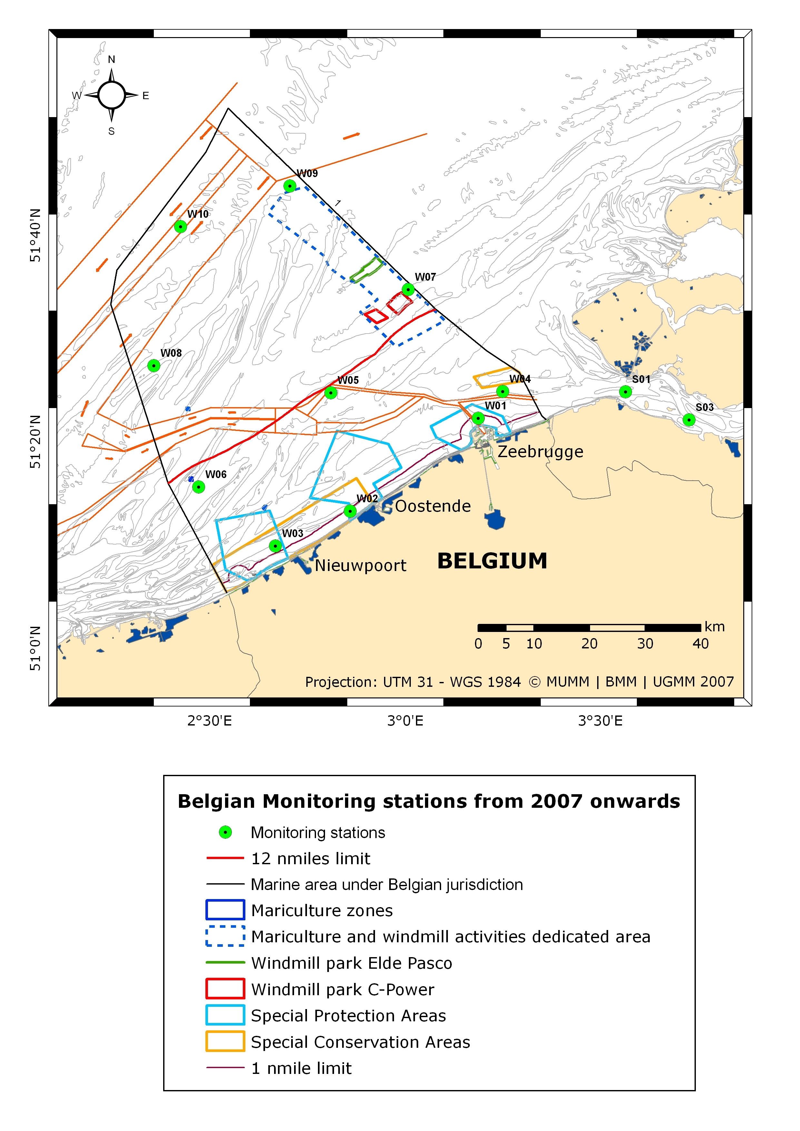
Figure 2. Location of the monitoring stations in the Belgian part of the North Sea from 2007 onwards.

This monitoring of the quality of the marine environment (water, sediments and biota) is undertaken by the Management Unit of the North Sea Mathematical Models (MUMM) in cooperation with the Institute for Agricultural and Fisheries Research (ILVO) and the Ghent University. In addition to water quality and related biological elements natural and anthropogenic activities and inputs and their effects are monitored by the MUMM. The monitoring results are gathered at national level in the BMDC database (at MUMM) and then integrated at international level in the database of the International Council for the Exploration of the Sea (ICES) for some parameters.

The monitoring results are subjected to joint international evaluations resulting in synopses such as the OSPAR Quality Status Reports and the reporting documents for the Water Framework Directive. An eutrophication assessment for the Belgian marine waters has been performed recently in 2007, as required by international agreements in the framework of OSPAR, for the period 2001 – 2005. The draft of the river basin management plan for the Belgian coastal waters for the implementation of the Water Framework Directive (2000/60/EC) includes an initial assessment of biological and chemical parameters until 2006 and the first results of the WFD compliant monitoring network of 2007. This plan is open for public consultation.

In addition, in 2003, a parallel programme for monitoring of nutrients, Chlorophyll-a and Suspended Matter (SPM) has been established by Flanders Marine Institute. Data is collected on a monthly basis, and is made publicly available for all research. (Note than the sampling sites are not the same as those of the OSPAR or other internaionational monitoring shemes).

- Belgian Federal Directorate General of Environment
www.health.fgov.be
- Management Unit of the North Sea Mathematical Models
www.mumm.ac.be
- Flanders Marine Institute
www.vliz.be

In the framework of several research projects carried out at the federal level in the framework of the “Science for a sustainable development” programme and previous phases tools and mechanisms, (including indicators) for marine and coastal ecosystems evaluation and assessment are developed
- The North Sea research programme of BELSPO
http://www.vlizbelspo.be/northsea
- Combined Effect of Changing Hydroclimate and Human Activity on Coastal Ecosystem Health (AMORE III)
http://www.belspo.be/belspo/fedra/proj.asp?l=en&COD=SD/NS/03A
- Integrated risk assessment and monitoring of micropollutants in the Belgian coastal zone (INRAM)
http://www.belspo.be/belspo/fedra/proj.asp?l=en&COD=SD/NS/02A
- Microbial diversity and metal fluxes in contaminated North Sea sediments (MICROMET)
http://www.belspo.be/belspo/fedra/proj.asp?l=en&COD=SD/NS/04A
- Quantification of Erosion/Sedimentation patterns to Trace the natural versus anthropogenic sediment dynamics (QUEST4D)
http://www.belspo.be/belspo/fedra/proj.asp?l=en&COD=SD/NS/06A

2.1: To promote ecosystem approaches to the conservation and sustainable use of marine and coastal living resources, including the identification of key variables or interactions, for the purpose of assessing and monitoring, first, components of biological diversity; second, the sustainable use of such components; and, third, ecosystem effects.

Through national and international research programmes, we attempt to improve our scientific insight in the functioning of the North Sea as an ecosystem, including the identification of key variables and interactions.
On the basis of this information, ecosystem approach is implemented in Belgium through a variety of programmes and instruments, the ecosystem approach lies at the basis of the Natura 2000 network of protected Areas, of the Integration of Coastal Zone Management as well as of the Water Framework Directive and the Marine Strategy Directive. For the national implementation of these instruments we refer to the answers to the other questions.
A Belgian Spatial Planning instrument has been developed, in order to create an integrated approach regarding the protection of the marine ecosystem and the management of all different human activities in the area (figure 3). In order to ensure policy integration a department for the North Sea within the federal administration and the function of a Minister of the North Sea have been created.
- The North Sea research programme of BELSPO
http://www.belspo.be/northsea
- Maes F., J. Schrijvers and A. Vanhulle (red.) (2005)
A flood of space : towards a spatial structure plan for sustainable management of the north sea (GAUFRE), Belgian Science Policy
http://www.belspo.be/belspo/home/publ/pub_ostc/MA/GaufreZVR_en.pdf

Barriers to implementation
The marine waters under Belgian jurisdiction is relatively small area that borders to the marine waters of France, the UK and the Netherlands. It is one of the most utilised marine areas in the world, home to a high variety of human activities. In addition, it is influenced by riverine runoff of the Scheldt and the Maas, which run through heavily populated, cultivated and industrialised areas.
The fact that many activities have an impact on the marine ecosystem, results in a fragmentation of competences. In order to successfully apply the ecosystem approach, a stronger coordination and integration is needed at both the national, European and international level.
At the research level, these barriers were partly overcome thanks to the Belgian participation (Belgian Science Policy) in the ERA-nets MARINERA (Co-ordination of National and Regional Marine RTD Activities in Europe) and AMPERA (European Concerted Action to foster prevention and best response to Accidental Marine Pollution).

Thus far, rhe efforts to develop a marine spatial management plan has no legal basis. Additional efforts are necessary to strengthen the spatial approach, and to ensure a correct implementation and enforcement of the spatial planning measures developed.

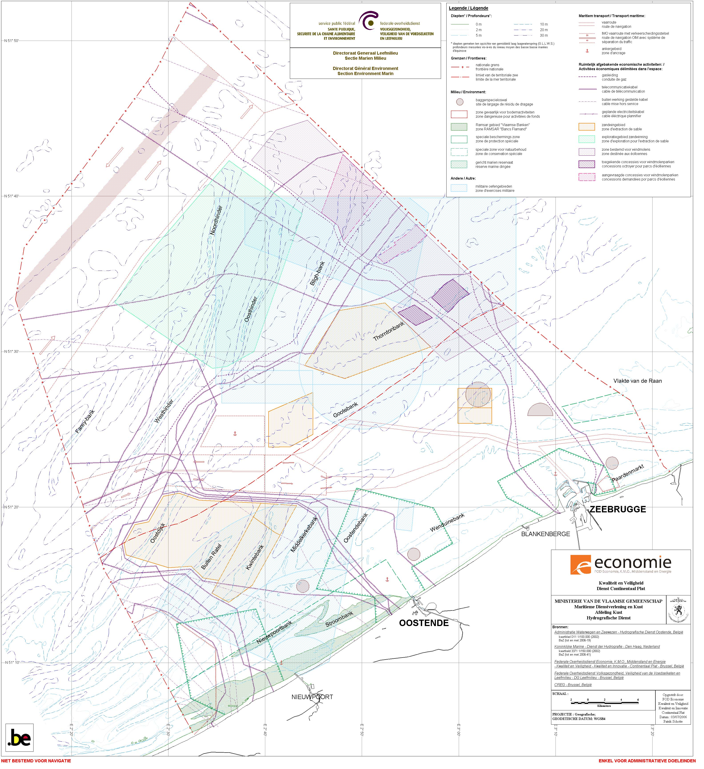
Figure 3 .Spatial Distribution of activities within the Belgian Part of the North Sea.

2.2: To make available to the Parties information on marine genetic resources in marine areas beyond national jurisdiction and, as appropriate, on coastal and marine genetic resources under national jurisdiction from publicly available information sources.

Belgium has communicated, through its national clearing house mechanism, an overview of the Belgian response to notification 2006-069, requesting information on research activities related to deep seabed genetic resources. In the following list this information is elaborated further.

1) Since about ten years, the Marine Geology section of the Ghent University is involved in research on deep sea coral reefs and mud volcanos situated at a depth of about 900 to 1200 metres on the continental edges of Ireland, Morocco, the Bay of Biscay and occasionnally Norway. More information:
This research is conducted in the framework of EC projects (CORSAIRES, GEOMOUND, ECOMOUND, EURODOM, OMARC, HERMES), IODP (Exp. 307), ESF EUROCORES projects MoundForce and MVSeis (Euromargins), MiCROSYSTEMS (EuroDiversity), etc.
2) The Laboratory of Animal Diversity and Systematics of the University of Leuven represents one of the three laboratories of the section Systematics and Ecology of Animals. Research focuses on various aspects of vertebrate diversity, with special attention to fish evolutionary genetics and speciation, parasitology, fish ecology and systematics, and archaeozoology. Whenever possible complementary approaches at the genetic, phenotypic, ecological and environmental level are used. A medium-throughput genotyping laboratory is fully operational. The laboratory cooperates with partners across Europe and North America, and in developing regions (projects in Ecuador, Southern and Central Africa). The research has applications in sustainable development, nature conservation, water and wildlife management, fisheries and aquaculture.
Studies on the biodiversity concern mainly African fresh- and brackish water fishes including aspects of conservation, fisheries and aquaculture. Some relevant coastal examples are:
- A revision of the small Barbus of Ivory Coast.
- Databases on African fresh and brackish water fishes, mainly FishBase and IUCN Red listing
3) The Research Group on Phycology of the Ghent University investigates the phylogeography of marine algae showing a disjunct distribution in the subtropical parts of the Indian Ocean. Molecular phylogenetic and phylogeographic techniques are applied on geographically isolated algal populations in the subtropical areas, in order to allow drawing conclusions whether these species have arrived by long distance dispersal, or have evolved towards similar forms in each of the areas separately.

4) The Marine Biology section of the Ghent University is involved in several international deep sea projects and networks (MAST FP2-3-4, ACES-FP5, HERMES FP-6, Chess-CoML, CoMarge-CoML). The expertise of the research group includes several aspects of meiobenthos ecology and taxonomy. A multi-method approach is used (molecular, morphological, ultra-structural, field or lab experimental, biomarkers, etc.) to understand the ecology and biodiversity of marine nematods, the dominant group of the meiobenthos. The section recently started research on population genetics of deep sea organisms. More information via .
5) The research programme ANDEEP investigates the deep sea around Antarctica since 2002.The CeDAMar website (CeDAMar = Census of the Diversity of Abyssal Marine Life gives a worldwide overview of the research on abyssal biodiversity, including the ANDEEP programme on Antarctica. URL: . A search on Google Scholar using the search string ANDEEP will provide a more complete overview of publications.
6) The Belgian Science Policy finances the project Biodiversity of Antarctic Zoobenthos (BIANZO). One of the aims of this project is the exploration of the hitherto unknown deep sea fauna of the continental slope and the abyssal plains of Scotia and the Weddell Sea. The project is a collaboration of four research groups: the Royal Belgian Institute of Natural Sciences, the Marine Biology section of the Ghent University, the Marine Laboratory of the Free University of Brussels and the Marine Laboratory of the Liege University. More information: and .
7) SCAR-MarBIN compiles and manages existing and new information on Antarctic marine biodiversity, and thus also on its deep sea biodiversity, by coordinating, supporting, completing and optimizing database networking. This information will in turn be sent to larger biodiversity initiatives such as OBIS, the information component of the Census of Marine Life (COML), and GBIF (Global Biodiversity Information Facility). More information: .
8) Research is conducted on the microbial biodiversity, more specifically on the archaebacteria, of sediments collected at depths ranging from 1.000 to 5.000 metres in the Weddell Sea and around the Antarctic peninsula.
Contributing Belgian experts: Jean-Pierre Henriet and Ann Vanreusel (Ghent University), Claude De Broyer and Bruno Danis (Royal Belgian Institute of Natural Sciences), David Cox (Belgian Science Policy)
Since the Belgian Science Policy has financed the following projects related to deep sea biodiversity BIANZO II (Biodiversity of three representative groups of the Antarctic Zoobenthos - Coping with Change) and PELAGANT (Status, Control and Rol of the Pelagic Diversity of the Austral Ocean):
BIANZOII will investigate biodiversity patterns of the Antarctic zoobenthos and their causal processes for three representative groups of different size categories: nematodes (meiobenthos), amphipods (macrobenthos) and echinoids (megabenthos). Trophodynamic aspects of these benthic groups and their ability to cope with temperature and temperature-related changes (food composition and availability, pH of the seawater...) will be studied mainly in an experimental approach. Information collected in previous studies and in the first two work packages will be used to initiate the development of a model about the possible changes in the benthic communities due to global environmental change
The PELAGANT project is an interdisciplinary study of the key components of the Austral Ocean Pelagic Ecosystem and deals with the criteria for the appearance, maintenance, and modification of biodiversity. The diversity and dynamics of this ecosystem are particularly sensitive to variations in physical structure of the ocean and in ice coverage, and are affected by climate changes. It is executed by two research groups from KULeuven and the University of Liege.
- Bianzo II
http://www.belspo.be/belspo/fedra/proj.asp?l=en&COD=SD/BA/02A
- Pelagant
http://www.belspo.be/belspo/fedra/proj.asp?l=nl&COD=EV/30
Regarding the North Sea and surrounding areas the Belgian Science Policy has funded the projects Trophos (Higher trophic levels in the Southern North Sea) and its successor Westbanks (Understanding benthic, pelagic and air-borne ecosystem interactions in shallow coastal seas) which aims for a better understanding of the links between the processes occurring in different parts (sediment, water column and air) of the marine ecosystem. Five research groups participated in these projects: Ghent University - Section Marine Biology, KULeuven - Laboratory of Aquatic Ecology, Research Institute for Nature and Forest, Flanders Marine Institute and Netherlands Institute of Ecology, Centre for Estuarine and Marine Ecology. Genetic analyses were performed by KULeuven on different marine species (P. minutus, Gyrodactylus, S. solea).
- Westbanks
http://www.belspo.be/belspo/fedra/proj.asp?l=en&COD=SD/BN/01A
- Trophos
http://www.belspo.be/belspo/fedra/proj.asp?l=en&COD=EV/25

2.3: To gather and assimilate information on, build capacity to mitigate the effects of, and to promote policy development, implementation strategies and actions to address:

(i) the biological and socio-economic consequences of physical degradation and destruction of key marine and coastal habitats including mangrove ecosystems, tropical and cold-water coral-reef ecosystems, seamount ecosystems and seagrass ecosystems including identification and promotion of management practices, methodologies and policies to reduce and mitigate impacts upon marine and coastal biological diversity and to restore mangrove forests and rehabilitate damaged coral reef; and in particular
As already referred to under point 1.2, national legislation and other measures are in place, frameworks for regional cooperation have been established, in order to protect the marine environment from negative impacts. Also through the national research programmes the biological and socio-economic impacts of the destruction of marine and coastal habitats are studied and policy development and implementation strategies are supported.
Relevant information is assimilated and made publicly available through a number of websites:
- Belgian Federal Directorate General of Environment
www.health.fgov.be
- Management Unit of the North Sea Mathematical Models
www.mumm.ac.be
- Flanders Marine Institute (VLIZ)
www.vliz.be
- Coastal Atlas
http://www.kustatlas.be
- International Scheldt Commission
www.isc-cie.com
- OSPAR
www.ospar.org
- Natura 2000 and the EU Birds and Habitats Directives
http://ec.europa.eu/environment/nature/index_en.htm
- The EU Water Framework DirectiveDirectives
http://ec.europa.eu/environment/water/water-framework/index_en.html
- The EU Marine Strategy Directive
http://ec.europa.eu/environment/water/marine/index_en.htm
- The EU Common Fisheries Policy
http://ec.europa.eu/fisheries/index_en.htm
- The EU website on IMCAM
http://ec.europa.eu/environment/iczm/home.htm
- International Council for the Exploration of the Sea (ICES).
http://www.ices.dk
- The North Sea research programme of BELSPO
http://www.belspo.be/northsea

(ii) the impacts of mangrove forest destruction, coral bleaching and related mortality on coral-reef ecosystems and the human communities which depend upon coral-reef services, including through financial and technical assistance.

This objective is not relevant with regard the marine waters under Belgian national jurisdiction. No national actions have been undertaken through the provision of financial or technical assistance specifically earmarked for this objective.

Nevertheless a project was funded by the Belgian Science Policy “Monitoring of coral reef in view of sustainable island development. Case study using hyperspectral remote sensing: Fordate, Tanimbar, Indonesia (KABAR)”. The general objective of this project, was the development of an efficient monitoring system for coral reef ecosystems based on hyperspectral remote sensing information in order to enhance the sustainable development of small island communities like on Pulau Fordata. More specifically, it aims to assess the condition of the coral reef benthic cover in the Pulau Fordata region using CASI hyperspectral data, to create a bathymetric model of the reef structures, and to develop generic data processing techniques and algorithms which can be applied to coral reefs worldwide.

In addition, the Marine Biology section and the Research Group on Phycology of the Ghent University are involved in several international projects and networks for research on tropical mangroves and coral reef biodiversity issues.

2.4: To enhance the conservation and sustainable use of biological diversity of marine living resources in areas beyond the limits of national jurisdiction

In the EU, the conservation and sustainable use of marine living resources falls under European Common Fisheries Policy. We therefore refer to the report of the EU Commission and to relevant information available online.
- The EU Common Fisheries Policy
http://ec.europa.eu/fisheries/index_en.htm
- International Council for the Exploration of the Sea (ICES).
http://www.ices.dk

The amount of Belgian fishing vessels active in the High Seas is limited. Measures are developed to limit the impact of Belgian fishing activities on the marine environment in general, inter alia through adaptation of fishery techniques.
In order to allow for a better integration of environmental consideration in the Belgian national fisheries policy, as well as the Belgian position within relevant international fora such as the EU, new measures are being developed to ensure an improved coordination between the various administrations involved. In 2009 a new coordination platform will established, which should ensure a stronger coordination and integration of fisheries and environmental policy-measures, both on the national, European and international level. This should improve coherency in the phase of policy development, as well as in the phase of the implementation of management measures.

3.1: To establish and strengthen national and regional systems of marine and coastal protected areas integrated into a global network and as a contribution to globally agreed goals.
The following marine protected areas, all situated inside territorial waters, have been designated by Royal Decrees (KB 14 October 2005 and KB 5 March 2006) in the Belgian part of the North Sea (see fig. 2):
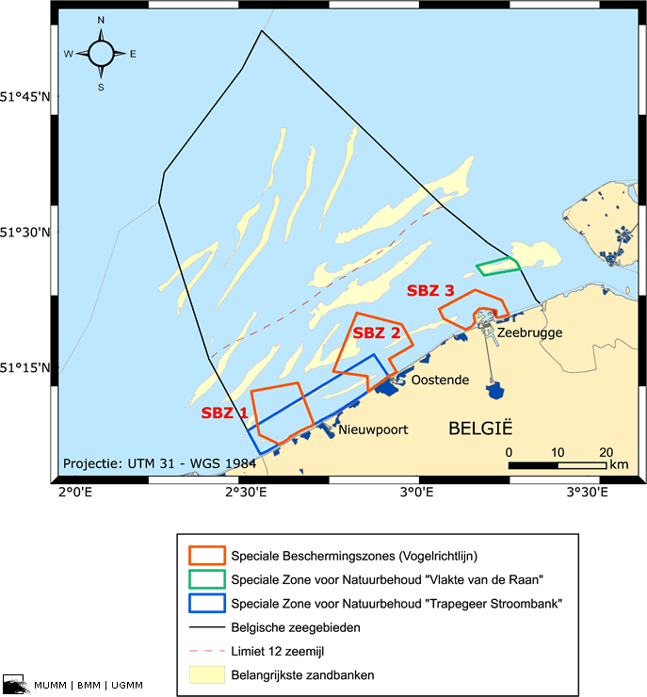Figure 2: Belgian Marine Protected Areas
Habitat Directive protection areas:
Trapegeer-Stroombank: 181 km2, situated between OstendOostend and the French border. Designated as Special Area of Conservation, conform the EU-Habitats Directive, with the aim to protect the sandbank habitat, Common Seal, Grey Seal, Harbour porpoise, Bottlenose Dolphin and White-beaked Dolphin and a number of fish species.
The Ramsar site “Vlaamse Banken” (Western Coastal Banks), designated in 1986, is entirely situated within the Trapegeer-Stroombank (max. depth, -6,0 m) and designated for the protection of migratory seabirds such as Common Scoter and for other migratory species as Loons and Grebes). http://ramsar.wetlands.org/Database/Searchforsites/tabid/765/Default.aspx
Vlakte van de Raan: area bordering the Dutch part of the North Sea. However, the designation of this area has been annulled by the Council of State. Hence, according to the Belgian law, this area is no longer protected. (Note that figure 2 does not yet reflects this recent development)
Bird Directive protection areas:
SBZ1: 110 Km2, situated in front of the western coast. Designated as Special Protection Area, conform the EU-Birds Directive for the protection of the Common Tern, Sandwich Tern, Great Crested Grebe, and the Little Gull and the species of the Ramsar Site (see above)
SBZ2: 144 Km2, situated in front of Ostend, central coast. Designated as Special Protection Area, conform the EU-Birds Directive for the protection for the same species as SBZ1.
SBZ3: 50 Km2, situated in front of Zeebrugge, eastern coast. Designated as Special Protection Area, conform the EU-Birds Directive for the protection of Common Tern, Sandwich Tern, Great Crested Grebe, and the Little Gull.
Marine Reserve “Baai van Heist”: 6 km2, situated next to SBZ3. Marine protected area for the conservation of the marine ecosystem (and associated habitats and species).
In addition, Belgium has commissioned a study to select additional marine protected areas in the EEZ to further contribute to the Natura 2000 network and network of MPAs. In the EEZ, an area of oyster reef has been located in Belgian waters, which is currently unprotected. The ecological value of this area is confirmed by the study (Haelters, J., Kerckhof, F. en Houzioux, J.-S. 2007. The designation of marine protected areas in the Belgian part of the North Sea: a possible implementation of OSPAR Recommendation 2003/3 in Belgium. Belgian Science Policy, RBINS, MUMM , Brussels (in Dutch) see http://www.belspo.be/belspo/Northsea/publ/OSPAR2007.pdf) The area consists primarily of reef-like structuresassociated with gravel and boulders on soft bottom and its protection is at this moment being considered.
In the draft policy plan (see below 3.3) the objective is formulated to consider the designation of additional sites under Natura 2000.
Belgium has a number of coastal protected areas, including two beach reserves: "De Baai van Heist" and "De IJzermonding" near Lombardsijde.
- The beach reserve "De Baai van Heist" (50 ha) is located on the beach plain created by sand and silt deposits in the lee of the eastern breakwater of the port of Zeebrugge. The bare beach plain has developed into a very diverse and dynamic coastal area. Under the lee of the wet beach on some thin covered beach banks, we now find a 'green beach' with embryonic dunes, silt, salt march and low dunes.
The dunes along the Belgian coast are very vulnerable ecosystems that have only recently been protected. The three largest nature reserves along the coast are "De Westhoek", "Het Zwin" and "Ter Yde".
- The dune complex "Ter Yde, the third largest dune complex along the coast, consists of a wide diversity of landscapes (coastal dunes, mobile dune massifs, dune forest, medieval dunes, wet dune valleys). It is one of the only places where the natural transition between sea and polders has been preserved over a 2,5 km wide dune strip. All nature reserves in the Ter Yde-complex are part of the Flemish Nature Reserve "Ter Yde", with as subareas 'Ter Yde' and 'Hannecartbos'. The total area managed by the Nature Devision (coastal conservation unit) is ca. 130 ha.
Areas along the coast where the natural transition between dunes and polders is still intact, transition dunes – polders, have become extremely rare.

- "Duinzoom Oosthoek" (16,5 ha), a part of the Flemish nature reserve 'De Duinen en Bossen van De Panne', is located in the ecologically highly valuable transition area between dunes and polders. Typical for this area is the very specific hydraulic regime and the variation in soil structure. The nature reserve consists of grazed wet grassland with ponds and ditches, flowery hayfields edged with pollard willow and a small strip a valuable inner dune woodland. An unpaved footpath forms the transition to the "Oosthoekduinen".

The estuary ecosystems of the Yser river creates a unique situation: it is the only place along the Belgian coast where a river flows directly into the sea.

- The ecosystem in the Flemish nature reserve "De Ijzermonding" (100 ha) is unique along the Belgian coast. The river estuary with its mudflats and salt marshes is directly connected to the beach, the coastal dunes, the grasslands and moss dunes situated further inland, and extends to the polders. The beach is an integral part of the nature reserve over a length of 1,100 m.

Forests along the coasts
Older forests along the coast can be found in the dunes and in the transition zone between the dunes and the polders. The original aim of the afforestation of the coastal dunes was to protect the agricultural lands in the hinterland. They form a wind screen and hold the sands together.
In the dune forest of De Haan you can clearly discern the successive vegetation belts in a dune area (see picture). As we move inland from the high-water mark we first find resistant grasses and herbs (marram, fescue...), subsequently bush species (creeping willow, sea buckthorn, elder...) and eventually timber. In the past conifer species (common pine, Corsican pine...) were planted behind a screen of native deciduous tree species (oak, maple...), but nowadays, they are being replaced by deciduous tree species. The most important dune forests along the western coast of Belgium are the Calmeynbos, the Doornpanne and the forest reserve Hannecartbos. Along the eastern coast we can find the Dune forests of De Haan and the Blinkaertbos and the Zwinbosjes in Knokke.
Nowadays coastal forests not only have an important environmental function but are of an explicit tourist-recreational importance as well. Forests are less easily affected by human activities than grassy dune areas. In addition, the capacity for walkers, cyclists and horsemen on the same surface is about 20 times higher than in open agricultural land.Forests are mainly visited in autumn and in spring because they offer the possibility to walk out of the wind. This is a major addition to beach tourism in summer as the tourist infrastructure of the coast can thus be used efficiently during a longer period of the year. For all these reasons new forests are being planted in the vicinity of the coast. To protect the historical 'open' picture of the polders this is done near urban environments and more precisely in areas where the scenery is already affected. These forests will replace the forests in the transition zone between the dunes and the polders. New forests have already been planted near Oostende (Keignaertbos) and Blankenberge (Zeebos). Other forests are planned near Nieuwpoort and Knokke.

Source:
- Coastal Atlas
(http://www.kustatlas.be)

3.2: To enhance the conservation and sustainable use of biological diversity in marine areas beyond the limits of national jurisdiction

Belgium remains to be a strong supporter of the development of additional measures to enhance the conservation and sustainable use of marine living resources in areas beyond national jurisdiction, and has actively participated in the various international negotiations.
The expert workshop thatwill take place in Canada in 2009 should address the lack of scientific information regarding the spatial distribution of biodiversity in ABNJ.
Nevertheless, important obstacles to the successful implementation of this point remain to exist:
- The limited mandate of the CBD in ABNJ
- The absence of an institutional framework under UNCLOS to implement the obligation of States to protect the marine environment in ABNJ, and the absence of a negotiating process for the establishment of such a framework.
- The lack of a process to ensure the consistency between protection measures developed under the different sector-based organisations, such as RFMOs, IMO, ISBA.
- The absence of sector-based organisations mandated to develop conservation measures for the biodiversity in areas under their jurisdiction, or the lack of implementation of these mandates.
- The absence of effective implementation and control mechanisms in ABNJ.

3.3: To achieve effective management of existing marine and coastal protected areas

In 2008, a policy plan (‘management plan’) was proposed with the objective to define a number of action priorities to maintain the state of conservation of the habitat types and species or to restore these to a ‘favourable state of conservation’. The policy plan has passed public consultation and is presently (Jan 2009) being considered by the competent minister.

The action plans focuses on:

- Measures to improve the marine environment (Good Environmental Status);
- Fishery measures (if needed in agreement with Guidelines of European Commission DG ENV and DG MARE),
- Measures to reduce disturbance to protected birds and sea mammals (recreation, national defence activities, …);
- Monitoring and surveillance (defining favourable state of conservation, setting up a monitoring and surveillance programme,
- Communication
- Actions with the aim to assess the effectiveness of the network of Marina Protected Areas (assessing the legal, administrative and financial problems).

3.4: To provide support for and facilitate monitoring of national and regional systems of marine and coastal protected areas

The necessary support for the monitoring of national and regional systems of marine and coastal protected areas, as part as the action plans for marine protected areas, will be provided.
The European research infrastructure Lifewatch – to which Belgium belongs- should provide support and facilitate monitoring of marine and coastal areas by bringing together data collected indepently at local and national levels and coming from different scales and sources (direct observation, existing monitoring and research programmes (e.g,MARBEF, EUROCEANS, ...) and large-scale biological and geological collections).

- Lifewatch
www.lifewatch.eu

3.5: To facilitate research and monitoring activities that reflect identified global knowledge gaps and priority information needs of management of marine and coastal protected areas.

Within the Belgian Federal Government's jurisdictional framework, the Belgian Science Policy implements national and international multiannual research actions with a view to consolidate Belgium's scientific and technological potential. A large number of its research projects are relevant to the management of the marine environment, including protected areas. More information can be found online.
Furthermore, the Belgian Biodiversity Platform is preparing a Biodiversity research strategy (to be ready by beginning of 2010), started by inviting vision documents from a series of stakeholders in biodiversity research, conservation, and management and followed up by a gap analysis of knowledge in Belgium (making use of BioBel database) and study of EPBRS recommendations (the european plaform on biodiversity research strategy) More information can be found online.
- Belgian Science Policy
http://www.belspo.be/
- The North Sea research programme of BELSPO
http://www.belspo.be/belsponorthseabelspo/fedra/pres_en.stm
- Belgian Biodiversity Platform
http://www.biodiversity.be/

In addition, relevant information on Belgian research projects can be found on the website of Flanders Marine Institute VLIZ
- Flanders Marine Institute
www.vliz.be
http://www.vliz.be/vmdcdata/wlist.php
In addition, Belgium has commissioned a study to select additional marine protected areas in the EEZ to further contribute to the Natura 2000 network of MPAs.

4.1: To promote use of techniques, which minimize adverse impact of mariculture on marine and coastal biological diversity.

In 2005, a permit was requested for the production of bivalve mollusks (mussels) in 4 different North Sea areas (see figure 4). The Management Unit of the North Sea Mathematical Models (MUMM) carried out the impact assessment study for the proposed activity. This resulted in an advice containing proposals for a series of conditions, the establishment of an environmental monitoring program and suggestions for the content of the annual activity report.

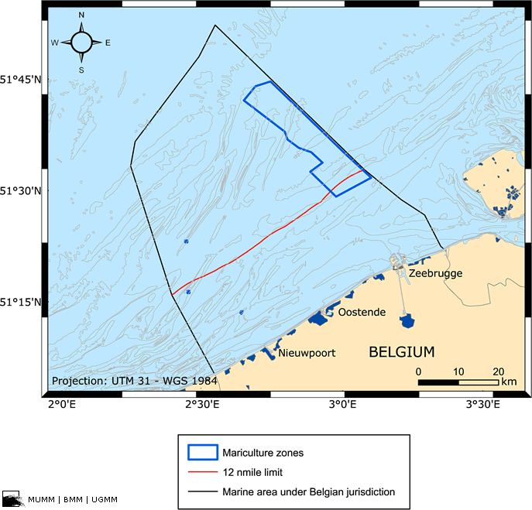
Figure 4. The four North Sea areas where the production of bivalve mollusks is permitted.

The following measures were instated in order to protect the marine environment:

- In case of damageto the ecosystem, to rare and endangered species or other natural resources, to protected areas or to human health the licensee will restore the site in its originally state
- The licensee needs to draw up an emergency plan (conform RD 7 September 2003).
- Sunken structures or components need to be removed by the licensee.
- No medication, nor any additional food sources, will be added.
- The licensee is obliged to report the occurrence of exotic species and the infection with parasites and diseases.

Note that the licence only permits the cultivation of mollusks, by the installation of artificial structures, but starting from seedlings naturally occurring in the North Sea.

5.1: To achieve better understanding of the pathways and the causes of the introduction of alien species and the impact of such introductions on biological diversity.

Every year a number of non-indigenous animals and plants arrive in the North Sea. These species are brought in from all over the world via aquaculture and shipping, on hulls or in the ballast water of ships.

Observations of exotic species in the Belgian part of the North Sea are reported by the MUMM to ICES (Working Group on Introduction and Transfers of Marine Organisms). The presence of exotic species however is not investigated on a regular base in the Belgian part of the North Sea.

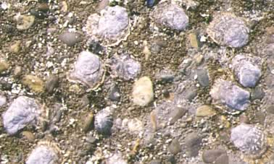
Figure 5. This image provides a detail of living pacific oysters on a groin on a beach of Ostend. They have a flattened form and thus don't show the well known 'cupped' form. This is due to the adaptation to this particular environment with its harsh living conditions.

There are currently around 120 known exotic plants and animals in the North Sea as a whole. This figure is probably underestimated, as it is sometimes difficult to find out whether or not the species are indigenous. In the Belgian part of the North Seaand adjacent estuaries, an estimated 68 alien species have actually settled and formed a resident population. The major breakthrough came a few centuries ago, during the major voyages of discovery overseas. Our climate is unsuited to many newcomers and after a while they die out. However, the number of species that adapt and remain here permanently is increasing sharply.

Some of them have even developed so strongly that they now form a dominant part of our marine flora and fauna. This is the case, for instance, with the American jack-knife clam (Ensis directus). This species was found in Belgian waters for the first time in 1987. Now the shells of this species are washed onto the Belgian beaches in their millions. Another recent example is the Japanese oyster (Crassostrea gigas). This species only became established here in the early 1990s, but now it can be found in huge numbers on groins and in our harbours.

Until recently only species were found that lived elsewhere in similar climates, but these days more (sub)tropical organisms become established in the North Sea. These species seem to feel perfectly at home here, because of the recent climate changes - the past ten years were the warmest of the last century. As a result, barnacles from New Zealand and the Mediterranean, shellfish from America and ascidians and algae from Japan now live along our coast.
The distribution of indigenous species is decreasing, due to competition of invasive alien species or due to the decrease of suitable habitat. The exponential growth of the mollusk Crepidula fornicata, introduced from North America, together with the Oyster, posed an immediate threat to the Belgian oyster culture in the 19th century. Another example of the dangers posed by introduction of invasive alien species is the effect such an introduction might have on reproduction of native species. For example, the American and native lobster do reproduce in the wild, however, the offspring is sterile, thus effecting the reproductive success of the native species.

So far noevidence exists of the fact that species indigenous to the North Sea have disappeared as a consequence of the introduction of an invasive alien species, which is not the case for our estuaries or inland waters.

Within the framework of the Belgian Biodiversity Platform a Belgian Forum on Invasive Species (BFIS) has been created. This forum gathers scientific information on presence, distribution, auto-ecology, adverse impacts and management of invasive alien species. It regularly updates a reference list of exotic species in Belgium and is responsible for the elaboration of a black list gathering species with a strong detrimental impact on biodiversity. BFIS has developped guidelines for environmental impact assessment on non-native species in Belgium (ISEIA protocol)

- Belgian Forum on Invasive Species
http://ias.biodiversity.be/ias/

5.2: To put in place mechanisms to control all pathways, including shipping, trade and mariculture, for potential invasive alien species in the marine and coastal environment.

The intentional introduction of exotic species in the Belgian part of the North Sea is forbidden by law (Art. 11 of the act of 20 January 1999 on the protection of the marine environment in sea areas under Belgian jurisdiction).

In 2004 the ‘Convention for the control and management of ships’ ballast water’ from the International Maritime Organization (IMO) was approved. As part of this regulation vessels are obligated to set up a “Ballast Water Management Plan” and to keep a “Ballast Water Record Book” on board with all ballast operations. This treaty is not yet ratified by Belgium.

Under the leadership of the UK (with sponsoring of a consortium of lands: Belgium, Germany, Netherlands, Norway, Sweden and the UK) a scoping study for the implementation of a regional management strategy for ballast water in North West Europe was initiated.

Also with regard to aquaculture, an increasing source of introductions, measures have to be taken. For instance, the licensee for the production of bivalve mollusks (mussels) in the Belgian part of the North Sea is obligated to report the occurrence of exotic species. There also exist some guidelines concerning aquaculture, for example .the ICES ‘Code of Practice on the Introductions and Transfers of Marine Organisms’ from 2004.

5.3: To maintain an incident list on introductions of alien species

Flanders Marine Institute (VLIZ) in collaboration with the VLIZ alien species consortium maintains a list of established alien (non-native) species and draws up information files for all settled/established alien species in the Belgian part of the North Sea and adjacent estuaries.

- VLIZ alien species consortium:
http://www.vliz.be/NL/Cijfers_Beleid/nietinheemsINTRO#partners)
- VLIZ list of non-native species in in the Belgian part of the North Sea and adjacent estuaries.
http://www.vliz.be/NL/Cijfers_Beleid/nietinheemsLIJST
- Belgian Forum on Invasive Species (BFIS)
http://ias.biodiversity.be/ias/
- Biodiversiteit in België - De opmars van exoten
http://www.belgium.be/nl/publicaties/pub_biodiversiteit_in_belgi_-_de_opmars_van_exoten.jsp

6.1: To assemble a database of initiatives on programme elements through a cooperative approach with relevant organizations and bodies, with special emphasis on integrated marine and coastal areas management.

A number of organisations in Belgium maintain a website with information initiatives relevant to the programme elements of the CBD Programme of Work for Marine and Coastal Biodiversity:
- Flanders Marine Institute develops and hosts a number of websites in support of Marine and coastal biodiversity conservation and management (http://www.vliz.be/vmdcdata/wlist.php?l=EN&cat=data). In addition VLIZ has developed expertise in the construction of databases and datamanagement in particular to biological databases. It includes i.a. Taxonomic database of marine species, that consists of several geographic registers and multiple world registers of several taxonomic groups (Aphia, World Register of Marine Species) and European Ocean Biogeographic Information System (EurOBIS).
- The Integrated Marine Information System: IMIS centralizes all information about topics relevant to Flemish marine sciences (people with their coordinates, projects, publications, datasets, ...). It is one of the basic services provided by VLIZ to the network of marine and coastal researchers.
- A reference database on biodiversity research and resources in Belgium (BioBel) is developed and maintained by the Belgian Biodiversity platform.
- With regard to policy related initiatives information can be found on the websites of the Federal Ministry of Environment (marine), of the Flemish Ministry of Environment and the Belgian Management Unit of the North Sea Mathematical Models.
- Flanders Marine Institute (VLIZ)
www.vliz.be
- BIOBEL - Belgian Biodiversity Platform
Flanders Marine Institute Integrated Marine Information System – IMIS
http://biobel.biodiversitywww.vliz.be/imis/
- VLIZ list of datasystems, databases and websites related to marine and coastal sciences and research
http://www.vliz.be/vmdcdata/wlist.php
- Federal Directorate General of Environment
www.health.fgov.be
- Flemish Ministry of Environment
www.vlaanderen.be
- Institute for Nature and Forest
www.inbo.be
- Belgian Management Unit of the North Sea Mathematical Models.
www.mumm.ac.be

6.2: To undertake effective collaboration, cooperation and harmonization of initiatives with relevant conventions, organizations and agencies while recognising their independent mandates.

The marine waters under Belgian jurisdiction (an area of3500km²) borders with the marine waters of France, the UK and the Netherlands. It is one of the most utilised marine areas in the world, home to a high variety of human activities. In addition, it is influenced by riverine runoff of the Scheldt and the Maas, which run through heavily populated, cultivated and industrialised areas.
Because of these strong interlinkages, it is important for Belgium to integrate its marine and coastal management on a higher, international, level. This coordination and integration takes place under a variety of organisations and conventions, but most important are the EU, OSPAR and ICES. Therefore Belgium is strongly involved in the policy development processes of these various bodies.

